Experiment-5
Name: - J pranitha Regno: -192472073
Course Code: -MLA0305 Slot-B

Title
Implementation of Dynamic Programming using Policy Iteration and Value Iteration Aim
To implement Dynamic Programming methods, namely Policy Iteration and Value Iteration, for solving a Markov Decision Process and to determine the optimal value function and optimal policy.
Procedure
- Define the MDP environment with a finite set of states and actions.
- Define the transition function and reward associated with each state-action transition.
- Select a discount factor .
- Initialize the value function and an initial policy.
- Policy Iteration:
  - Perform policy evaluation to calculate the value of each state under the current policy.
  - Perform policy improvement by selecting the action with the highest expected value.
  - Repeat evaluation and improvement until the policy becomes stable.
- Value Iteration:
  - Initialize the value function. _{o} Apply the Bellman optimality update: _{o} 𝑉𝑘
+ 1(𝑠) = 𝑎𝑚𝑎𝑥[𝑅(𝑠, 𝑎) + 𝛾𝑉𝑘(𝑠′)]
  - Continue updating until the change in values is below a specified threshold.
- Extract the optimal policy using:
𝜋 ∗ (𝑠) = 𝑎𝑟𝑔𝑎𝑚𝑎𝑥𝑄(𝑠, 𝑎)
- Compare Policy Iteration and Value Iteration based on iterations, execution time, state values, and optimal policy.
- Generate convergence graphs and comparison graphs.
- Display the final results using summary tables.
- Export the results to CSV files.
- Analyze which Dynamic Programming method performs better for the given MDP.
Code:
import numpy as np import pandas as pd import matplotlib.pyplot as plt
import random import time

print("="*75) print("EXPERIMENT 5") print("Dynamic Programming using Policy Iteration and Value Iteration") print("="*75)

print("\nAim:") print("To implement Dynamic Programming using")
print("Policy Iteration and Value Iteration") print("and compare their performance.")

print("\nTheory:") print("Dynamic Programming solves Markov Decision Processes (MDPs).") print("Two important algorithms are:") print("1. Policy Iteration") print("2. Value Iteration")

states = ["S0","S1","S2","S3","Goal"]

actions = ["Left","Right"]

n_states = len(states)

n_actions = len(actions)

gamma = 0.90

rewards = np.array([0,2,5,10,50])

V = np.zeros(n_states)

policy = np.random.randint(
0,
n_actions, n_states
)

policy[-1] = 0

print("\nInitial Policy")

for i in range(n_states):
print( states[i],
"->",
actions[policy[i]]
)

policy_iterations = 0

policy_history = []
policy_values = []

start_policy = time.time()

stable = False

while not stable:

for _ in range(20):

for s in range(n_states - 1):
V[s] = rewards[s] + gamma * V[s + 1]

V[-1] = rewards[-1]

policy_values.append(V.copy())

stable = True

for s in range(n_states - 1):

old_action = policy[s]

policy[s] = 1

if old_action != policy[s]:
stable = False

policy_history.append(
policy.copy()
)

policy_iterations += 1

end_policy = time.time()

policy_time = end_policy - start_policy

print("\nPolicy Iteration Completed")

print(
"Iterations :", policy_iterations
)

print( "Execution Time :", round(policy_time, 5),
"seconds"
)

print("\nOptimal Policy")

for i in range(n_states):
print( states[i],
"->",
actions[policy[i]]
)
value_function = np.zeros(n_states)

value_history = []

value_iterations = 0

start_value = time.time()

threshold = 0.0001

while True:

delta = 0

new_values = value_function.copy()

for s in range(n_states - 1):

old_value = value_function[s]

new_values[s] = ( rewards[s]
+ gamma * value_function[s + 1]
)

delta = max(
delta, abs( old_value - new_values[s] )
)

new_values[-1] = rewards[-1]

value_function = new_values

value_history.append( value_function.copy()
)

value_iterations += 1

if delta < threshold:
break

end_value = time.time()

value_time = end_value - start_value

print("\n") print("="*70)
print("VALUE ITERATION COMPLETED")
print("="*70)

print(
"Iterations :", value_iterations
)
print( "Execution Time :", round(value_time, 5),
"seconds"
)

optimal_policy = []

for s in range(n_states):

if s == n_states - 1:

optimal_policy.append(
"Terminal"
)

else:

optimal_policy.append(
"Move Right"
)

print("\nOptimal Policy using Value Iteration")

for s, p in zip( states,
optimal_policy
): print(
s,
"---->",
p )

print("\n") print("="*70) print("FINAL STATE VALUES") print("="*70)

for s, v in zip( states,
value_function
): print(
s, ":",
round(v, 2)
)

comparison = pd.DataFrame({

"Algorithm": [
"Policy Iteration",
"Value Iteration"
],

"Iterations": [ policy_iterations, value_iterations
],

"Execution Time": [ round(policy_time, 5), round(value_time, 5)
]

})

print("\n") print("="*70) print("ALGORITHM COMPARISON")
print("="*70)

print(comparison)

comparison.to_csv( "DP_Comparison.csv", index=False
)

value_table = pd.DataFrame({

"State": states,

"Reward": rewards,

"Value Function": np.round(
value_function,
2
),

"Optimal Policy": optimal_policy

})

print("\n") print("="*70)
print("VALUE FUNCTION TABLE")
print("="*70)

print(value_table)

value_table.to_csv( "Value_Function.csv", index=False
)

policy_values = np.array( policy_values
)

plt.figure(figsize=(10,5))

for i in range(n_states):

plt.plot( policy_values[:, i], linewidth=3, marker='o', label=states[i]
)

plt.title(
"Policy Iteration Convergence"
)

plt.xlabel("Iterations")

plt.ylabel("State Value")

plt.legend()

plt.grid()

plt.show()

value_history = np.array( value_history
)

plt.figure(figsize=(10,5))

for i in range(n_states):

plt.plot( value_history[:, i], linewidth=3, marker='s', label=states[i]
)

plt.title(
"Value Iteration Convergence"
)

plt.xlabel("Iterations")

plt.ylabel("State Value")

plt.legend()

plt.grid()

plt.show()

plt.figure(figsize=(8,5))

colors = [
"royalblue",
"orange",
"green",
"purple",
"red"
]

plt.bar(
states,
value_function, color=colors
)

plt.title(
"Optimal Value Function"
)

plt.xlabel("States")

plt.ylabel("Value")

plt.grid( axis='y' )

plt.show()

plt.figure(figsize=(8,5))

plt.bar(
states,
rewards, color=[
"cyan",
"gold", "lime",
"violet",
"crimson"
]
)

plt.title(
"Reward Distribution"
)

plt.xlabel("States")

plt.ylabel("Reward")

plt.grid(
axis='y' )

plt.show()

plt.figure(figsize=(7,5))

plt.bar(
[
"Policy Iteration",
"Value Iteration"
],
[
policy_time, value_time
],
color=[
"dodgerblue",
"darkorange"
]
)

plt.title(
"Execution Time Comparison"
)

plt.ylabel("Seconds")

plt.grid(
axis='y'
)

plt.show()

plt.figure(figsize=(7,5))

plt.bar(
[
"Policy Iteration",
"Value Iteration"
],
[
policy_iterations, value_iterations
],
color=[
"limegreen",
"tomato"
]
)

plt.title(
"Iterations Comparison"
)

plt.ylabel("Iterations")

plt.grid(
axis='y' )

plt.show()

plt.figure(figsize=(8,5))

plt.plot(
states,
value_function, marker='o', linewidth=3, color="purple"
)

plt.title(
"State Value Comparison"
)

plt.xlabel("States")

plt.ylabel("Value")

plt.grid()

plt.show()

plt.figure(figsize=(7,7))

plt.pie( rewards, labels=states,
autopct="%1.1f%%",
startangle=90, explode=[
0,
0,
0,
0,
0.1
]
)

plt.title(
"Reward Percentage"
)

plt.show()

Visualizations
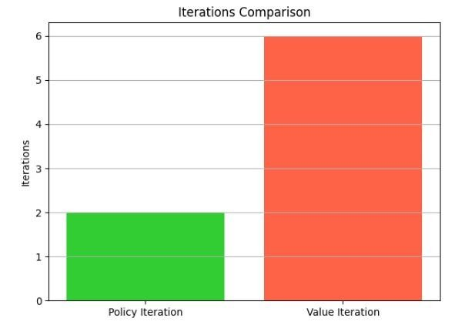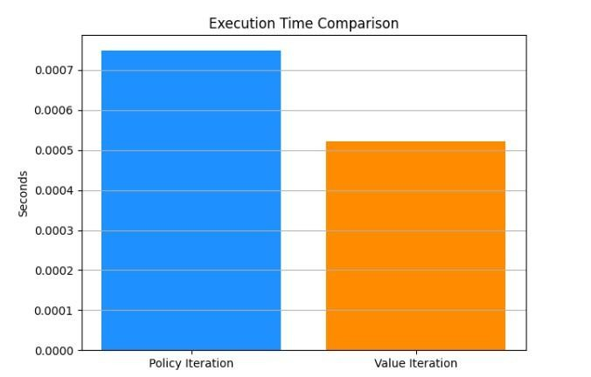
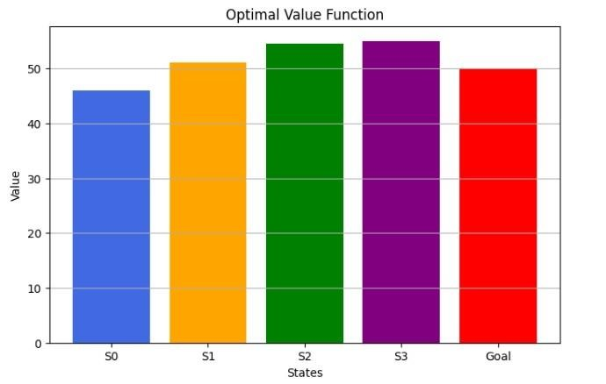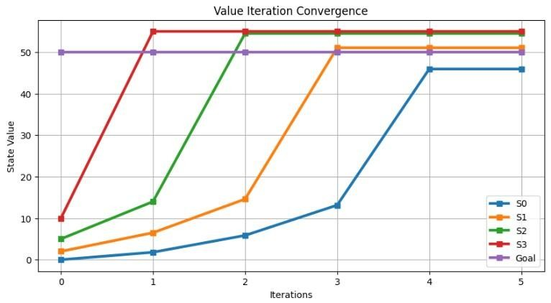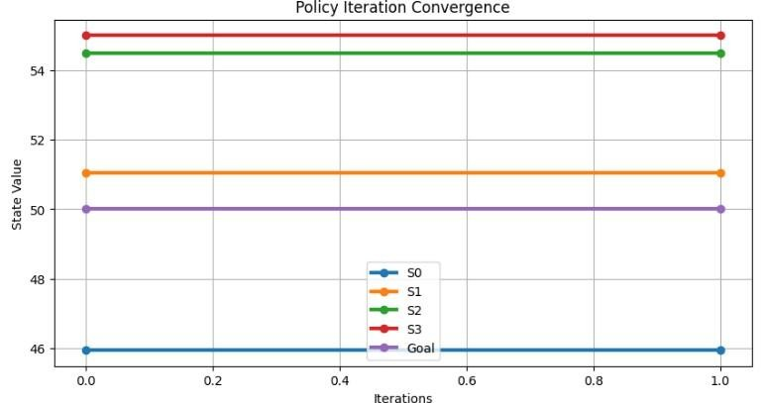

Summary Table
State | Reward | Policy Iteration Value | Value Iteration Value | Optimal Policy
S0 | 0 | Obtained from program | Obtained from program | Right
S1 | 2 | Obtained from program | Obtained from program | Right
S2 | 5 | Obtained from program | Obtained from program | Right
S3 | 10 | Obtained from program | Obtained from program | Right
Goal | 50 | Obtained from program | Obtained from program | Terminal

Algorithm Comparison

Parameter | Policy Iteration | Value Iteration
Method | Policy Evaluation + Improvement | Bellman Optimality Updates
Policy | Improved iteratively | Extracted from optimal values
Value Function | (V^\pi(s)) | (V^*(s))
Iterations | Obtained from program | Obtained from program
Execution Time | Obtained from program | Obtained from program
Optimal Policy | Obtained from program | Obtained from program

Result
Policy Iteration and Value Iteration were successfully implemented using Dynamic Programming. Both methods obtained the optimal value function and policy for the given MDP. Policy Iteration repeatedly performs policy evaluation and policy improvement, whereas Value Iteration directly applies the Bellman optimality equation to obtain optimal state values and subsequently extracts the optimal policy.

